**DEPARTMENT PART**

**Executive Officer**

**“Application Receipt by Executive Officer”**

**Step 1:**

Login as “**Executive Officer**” in Service plus web portal.

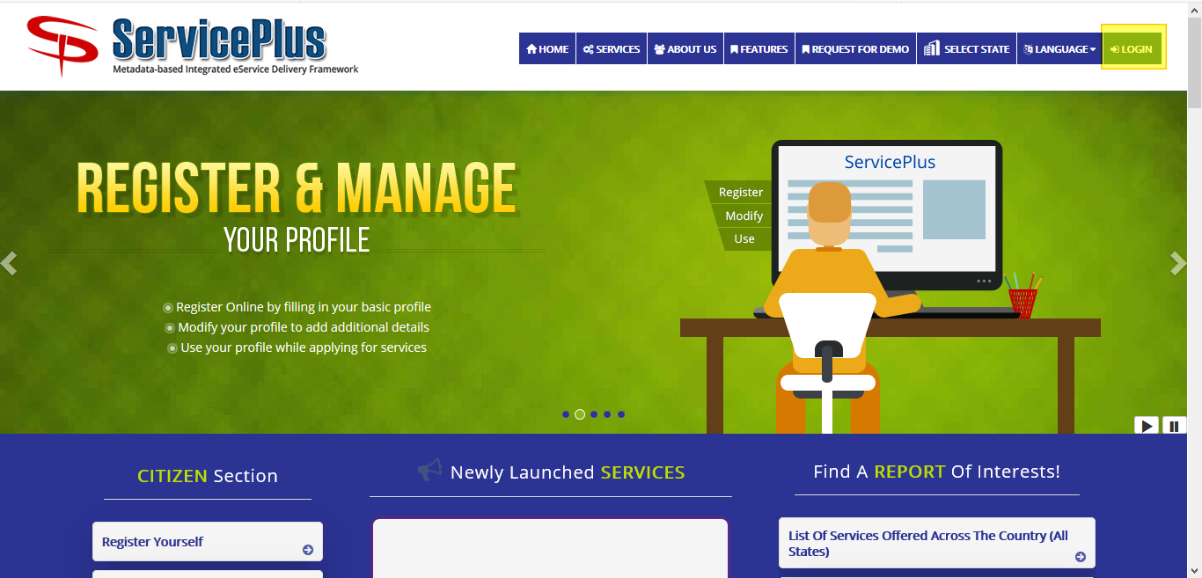

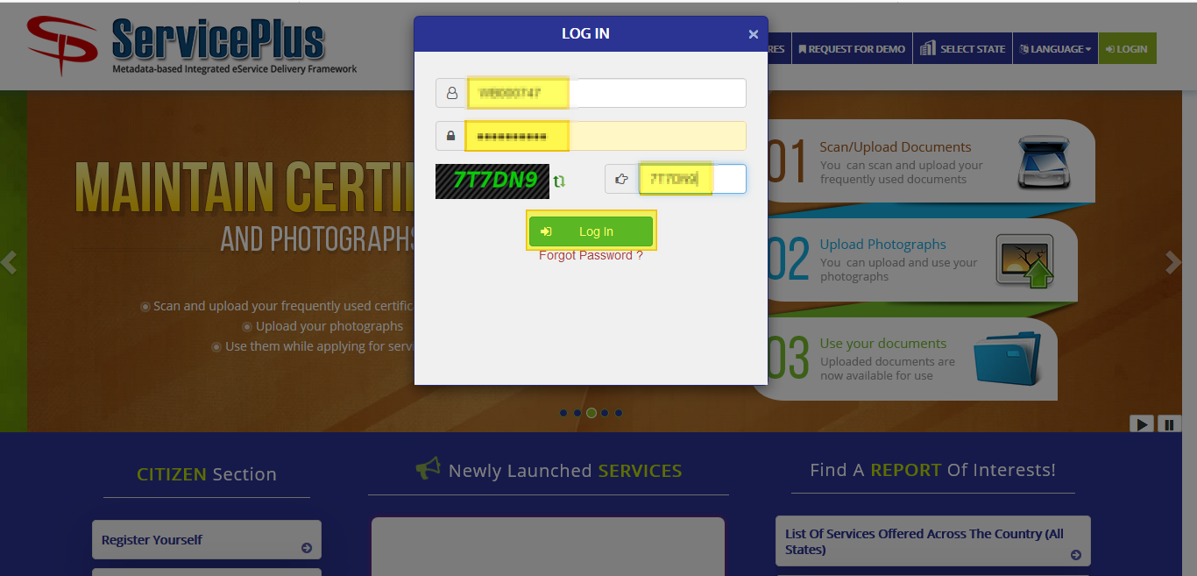

**Step 2:**

Now Go to **“Message Box”** and select **“Inbox”**.

In Inbox select the service **“Application for Registration of Migrant Labour”** and select the task **“Application Receipt by Executive Officer”** and select **“Get Data”.**

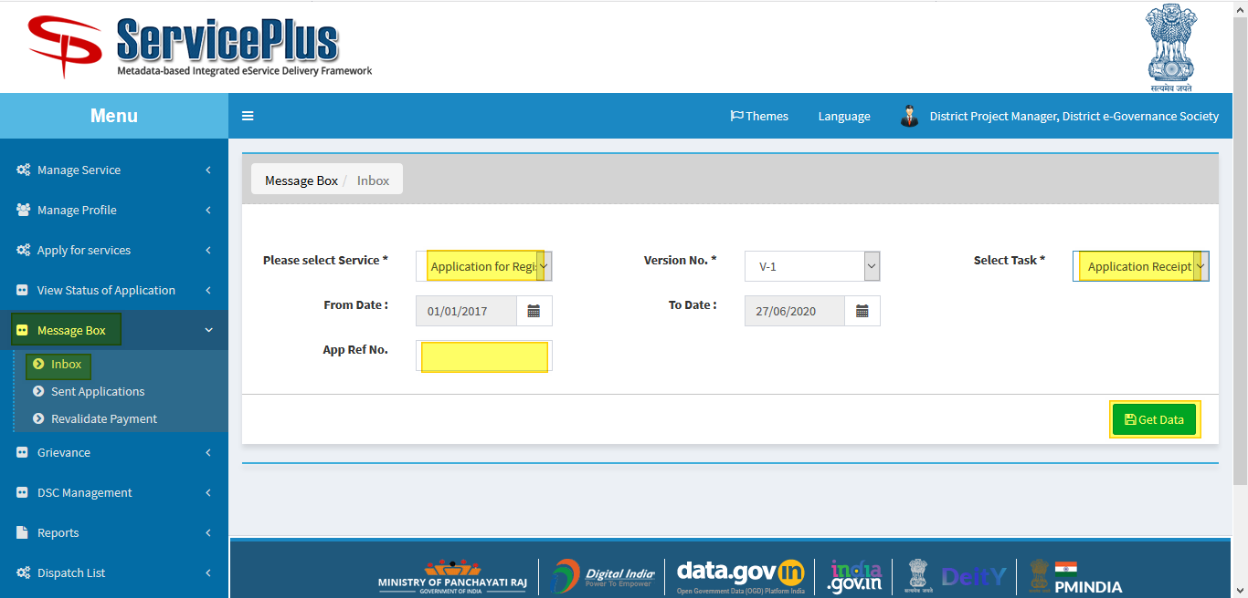

**Step 3:**

Select **“Pull”/ “Take Action”** to take action.

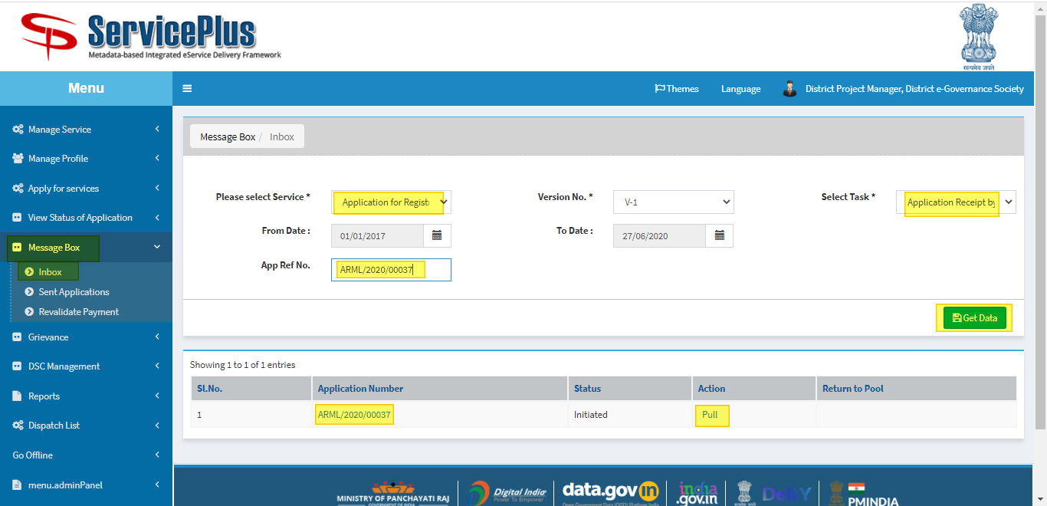

**Step 4:**

Select **“View Processing History”** to see the history of the application.

Action of the form can be taken by **Executive Officer** by taking action in two steps to **Reject** or **Forward**.

* By selecting reject and submit it directly rejects the application.
* By Selecting Forward to **Executive Officer** you may have to update the database by clicking the button **“Update Labour Details”** to enable submit button.

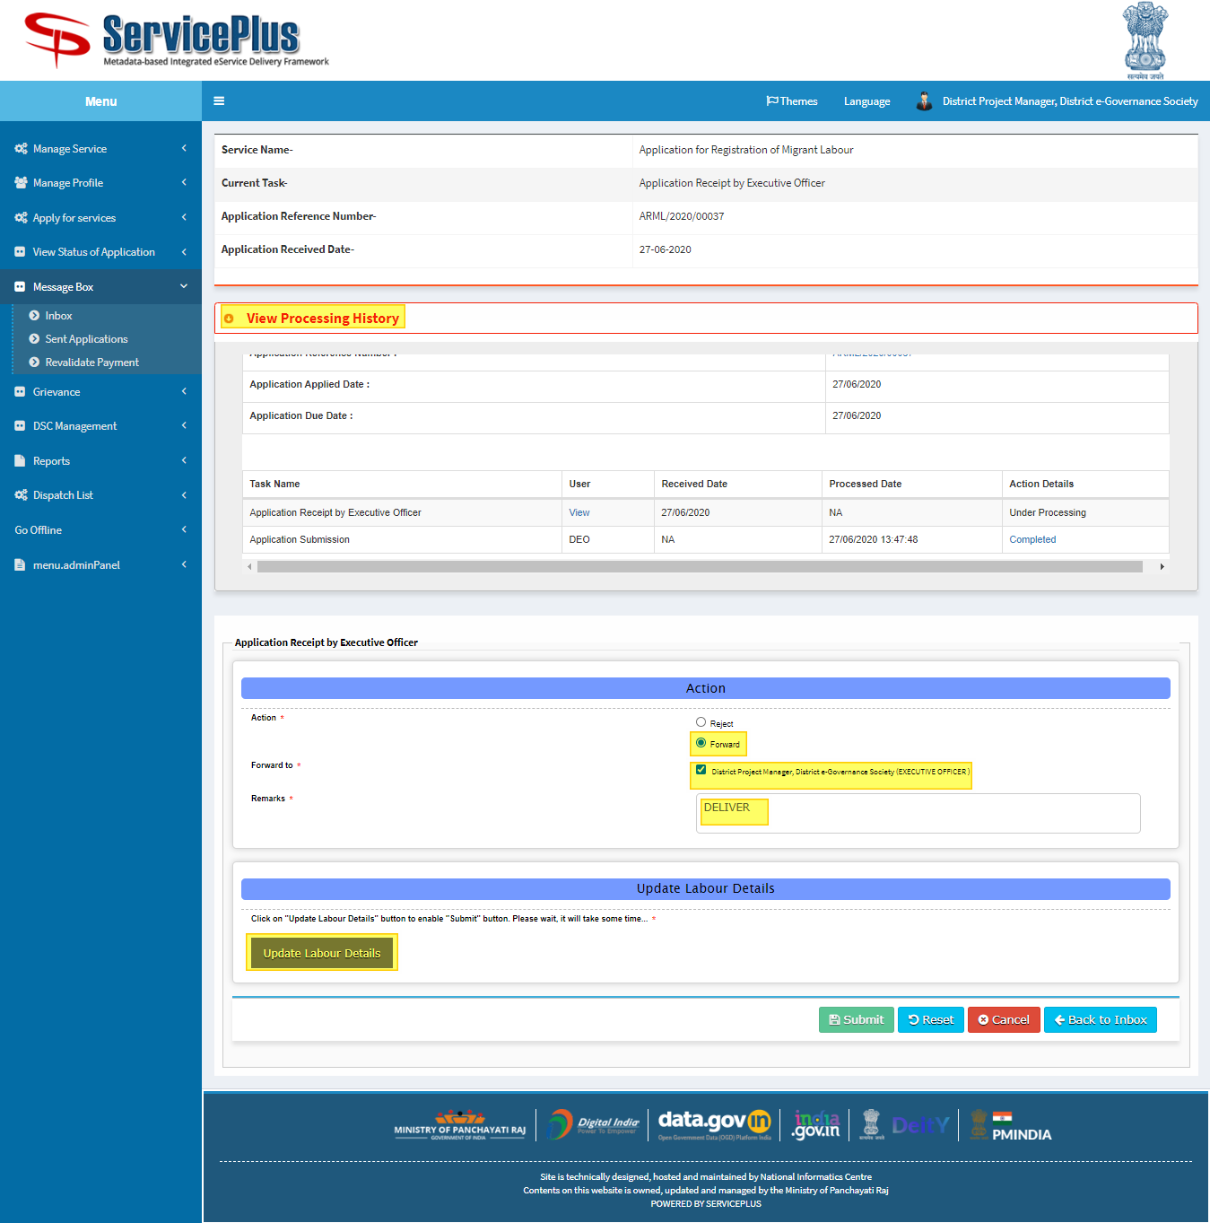

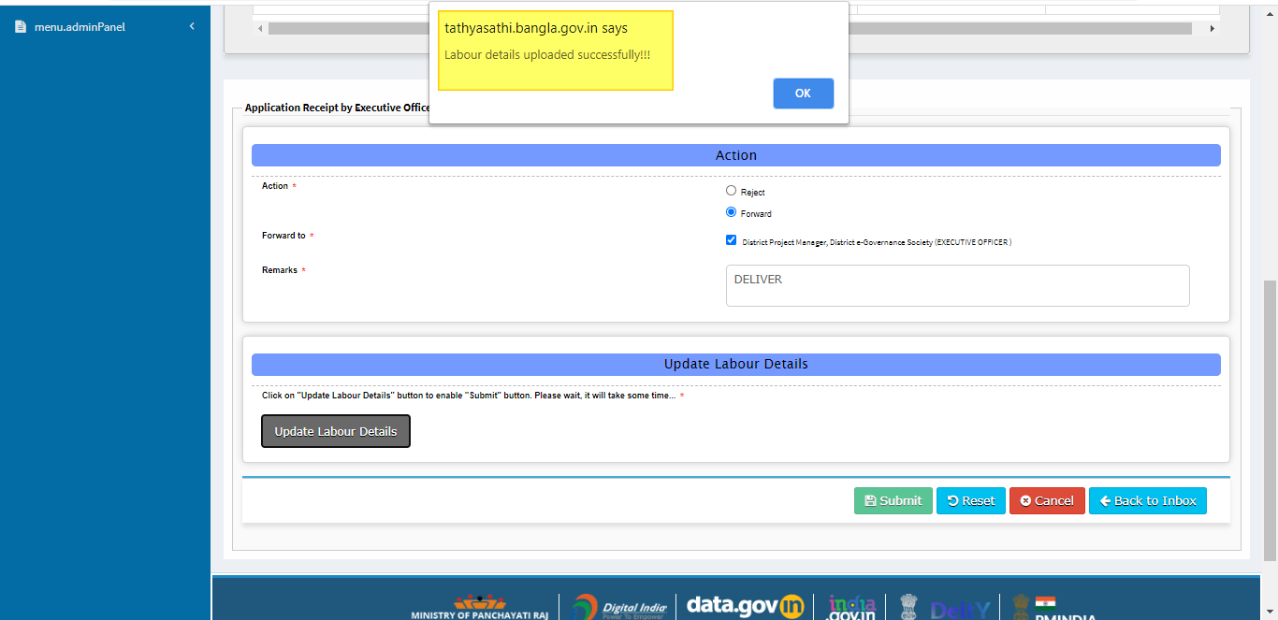

**Step 5:**

Now the Submit Button is enable to submit.

And by submitting it go to Executive Office to take action deliver and search.

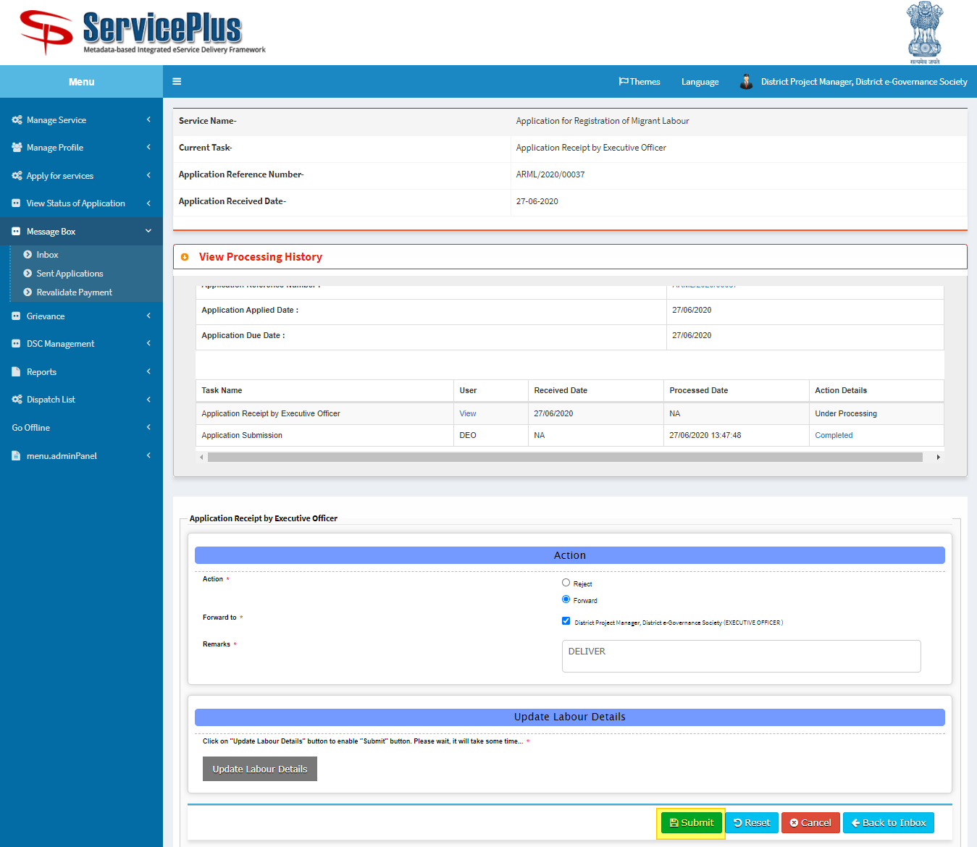

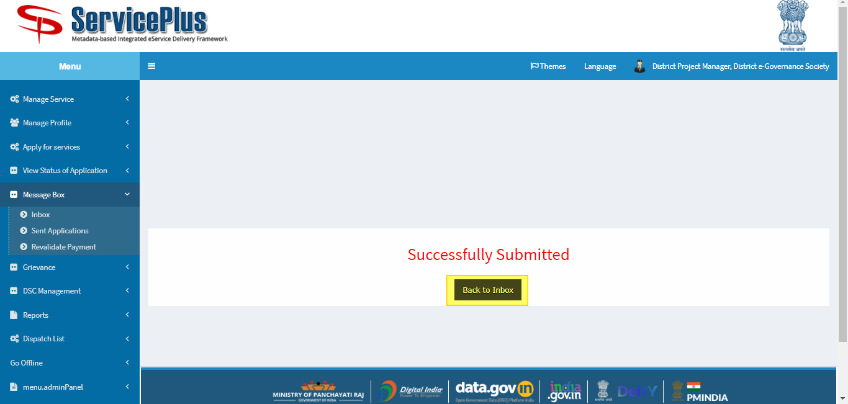

**Executive Officer**

**“Application Issuance by Executive Officer”**

**Step 6:**

By clicking **“Back to Inbox”.**

In Inbox select the service **“Application for Registration of Migrant Labour”** and select the task **“Issuance Certificate by Executive Officer”** and select **“Get Data”.**

Select **“Pull” / “Take Action”**.

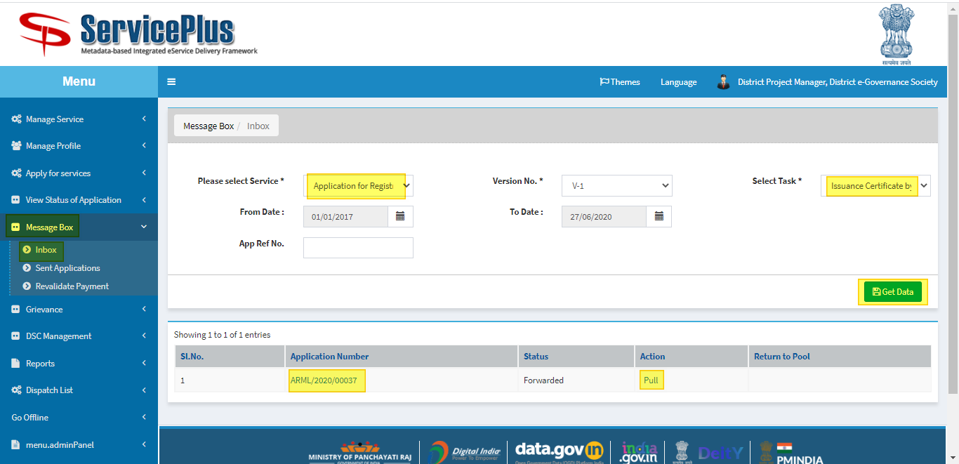

**Step 7:**

Select **“View Processing History”** to see the history of the application.

Action of the form can be taken by **Executive Officer** by taking action to **Deliver**.

* **“Search**” button is to be clicked to enable the submit button and allot employee.
* If Employee is not allotted then it takes to **Step 8** otherwise **Step 9**.

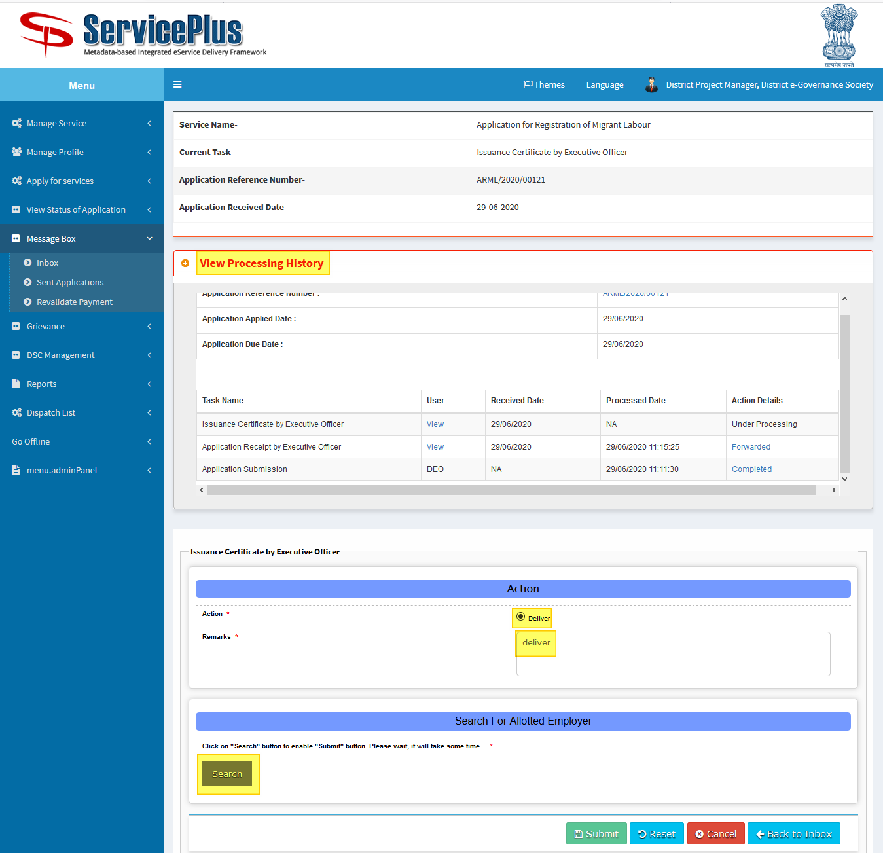

**Step 8:**

If Employee not allotted.

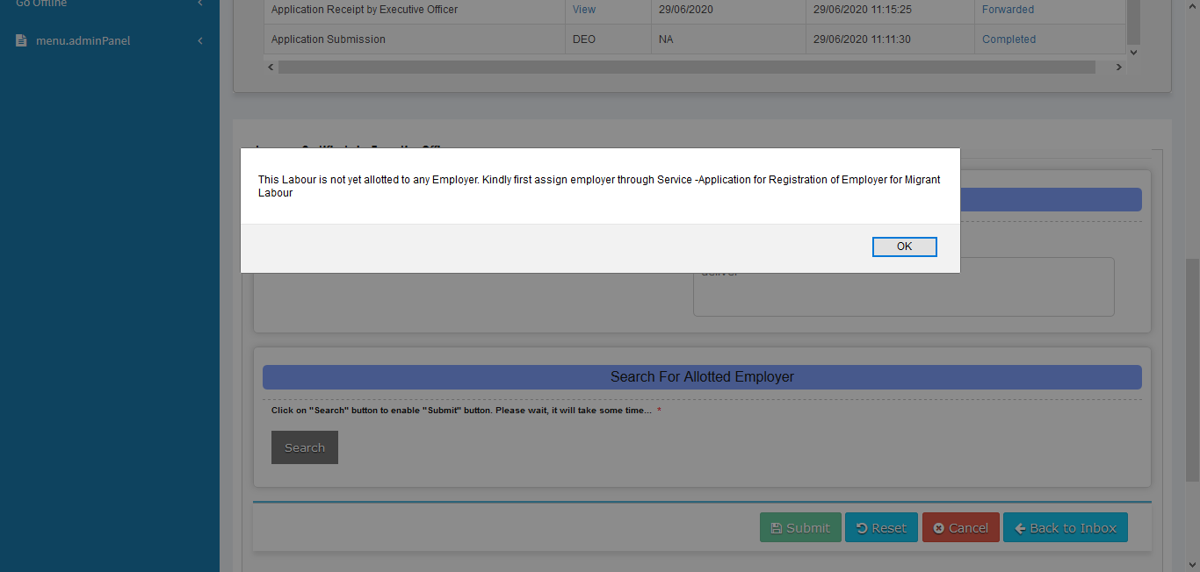

**Step 9:**

Otherwise.

Submit button is enabled.

Submit it to deliver.

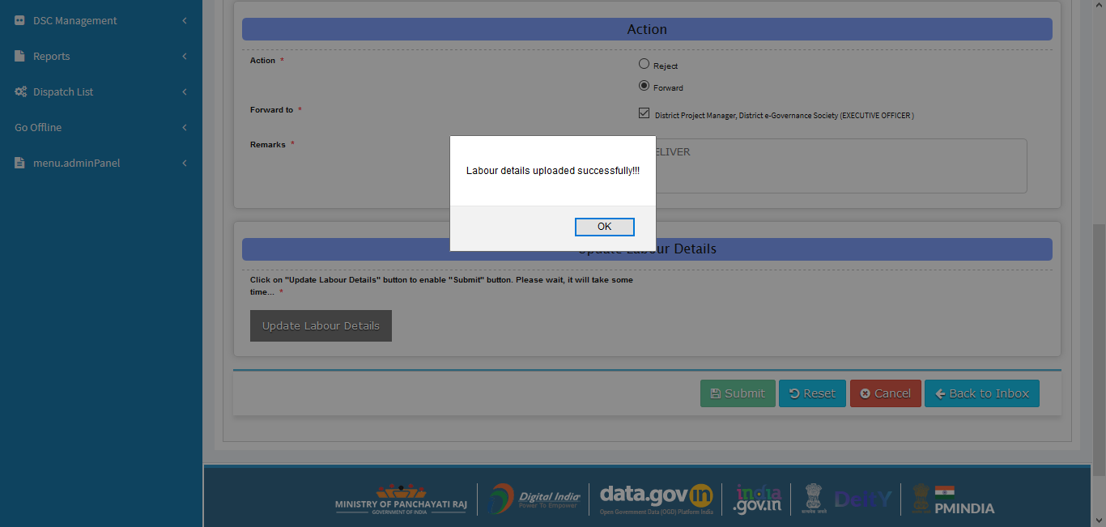

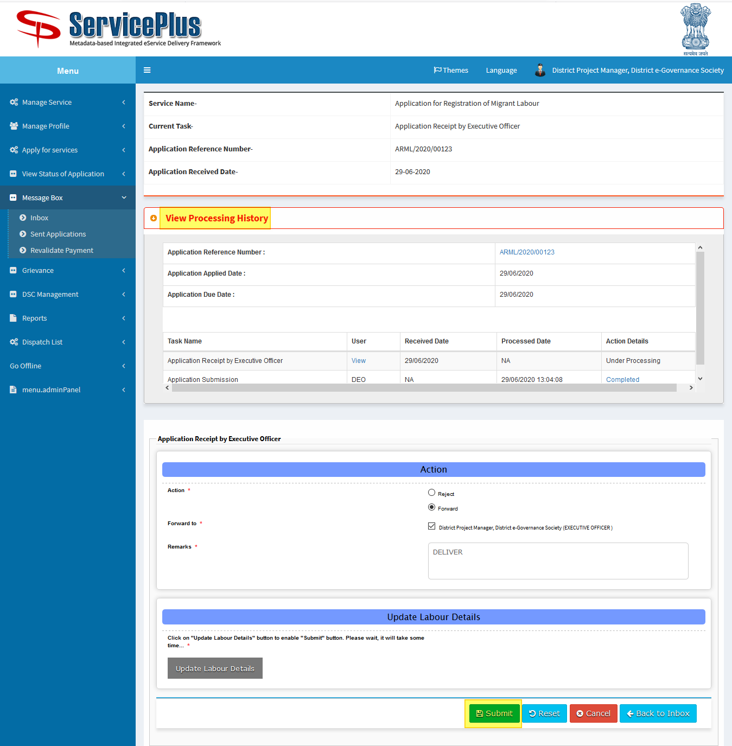

**Step 10:**

Here document can be downloaded by clicking the file icon and submit.

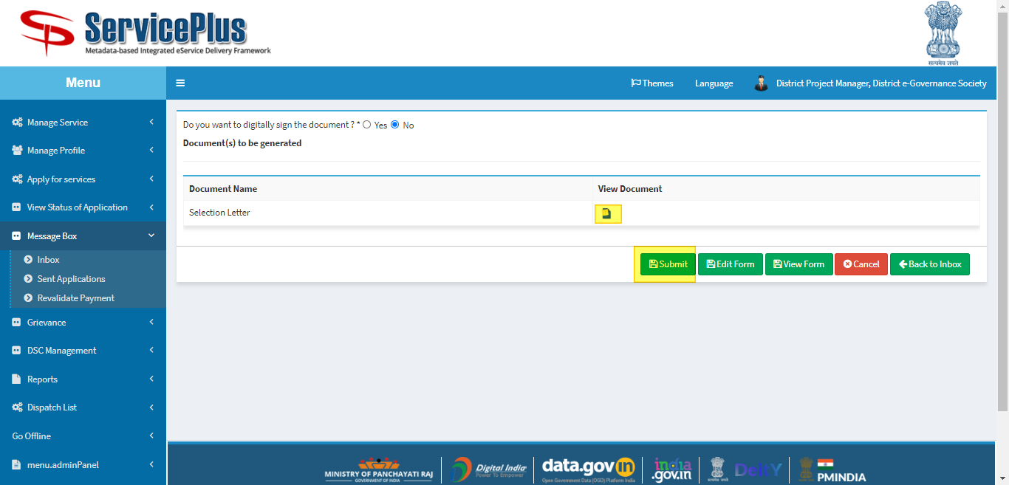

**Step 11:**

Here is an example document.

